FNGU

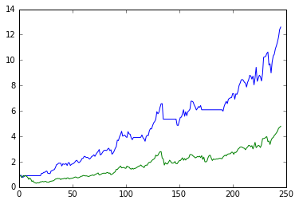

|  | dt | type | price | size | value | commission | pnl |
| --- | --- | --- | --- | --- | --- | --- | --- |
| 0 | 2020-02-25 | buy | 8.779900 | 11293 | 99151.406151 | 743.635546 | 0.000000 |
| 1 | 2020-02-26 | buy | 8.100000 | 12 | 97.200005 | 0.729000 | 0.000000 |
| 2 | 2020-03-02 | sell | 8.015000 | -11305 | 99248.606155 | 679.571842 | -8639.027274 |
| 3 | 2020-03-24 | buy | 3.010000 | 29627 | 89177.269717 | 668.829523 | 0.000000 |
| 4 | 2020-03-25 | buy | 3.660000 | 24 | 87.840002 | 0.658800 | 0.000000 |
| 5 | 2020-03-26 | sell | 3.950000 | -29651 | 89265.109720 | 878.410886 | 27856.341694 |
| 6 | 2020-03-30 | buy | 3.639000 | 31675 | 115265.323067 | 864.489923 | 0.000000 |
| 7 | 2020-03-31 | buy | 3.886000 | 29 | 112.693998 | 0.845205 | 0.000000 |
| 8 | 2020-04-16 | sell | 5.984000 | -31704 | 115378.017064 | 1422.875569 | 74338.725466 |
| 9 | 2020-04-20 | buy | 5.879000 | 31758 | 186705.287936 | 1400.289660 | 0.000000 |
| 10 | 2020-04-21 | buy | 5.903000 | 31 | 182.992996 | 1.372447 | 0.000000 |
| 11 | 2020-04-22 | buy | 5.227000 | 1 | 5.227000 | 0.039203 | 0.000000 |
| 12 | 2020-04-23 | sell | 5.697000 | -31790 | 186893.507933 | 1358.307231 | -5785.877084 |
| 13 | 2020-04-27 | buy | 5.918000 | 30117 | 178232.412663 | 1336.743095 | 0.000000 |
| 14 | 2020-04-28 | buy | 6.166000 | 29 | 178.813997 | 1.341105 | 0.000000 |
| 15 | 2020-07-27 | sell | 13.047000 | -30146 | 178411.226660 | 2949.861449 | 214903.633270 |
| 16 | 2020-08-05 | buy | 14.445000 | 26796 | 387068.211823 | 2903.011589 | 0.000000 |
| 17 | 2020-08-10 | buy | 14.504000 | 26 | 377.103992 | 2.828280 | 0.000000 |
| 18 | 2020-08-11 | buy | 14.170000 | 1 | 14.170000 | 0.106275 | 0.000000 |
| 19 | 2020-09-03 | sell | 20.108000 | -26823 | 387459.485815 | 4045.176590 | 151897.392864 |
| 20 | 2020-09-23 | buy | 17.677999 | 30026 | 530799.612881 | 3980.997097 | 0.000000 |
| 21 | 2020-09-28 | buy | 17.285000 | 30 | 518.549995 | 3.889125 | 0.000000 |
| 22 | 2020-10-26 | sell | 20.400000 | -30056 | 531318.162876 | 4598.567914 | 81824.225658 |
| 23 | 2020-11-23 | buy | 19.799000 | 30477 | 603414.116489 | 4525.605874 | 0.000000 |
| 24 | 2020-11-25 | buy | 20.799000 | 29 | 603.170994 | 4.523782 | 0.000000 |

XENE

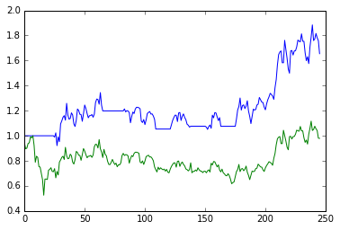

|  | dt | type | price | size | value | commission | pnl |
| --- | --- | --- | --- | --- | --- | --- | --- |
| 0 | 2020-03-30 | buy | 11.00 | 9014 | 99154.000000 | 743.655000 | 0.000000 |
| 1 | 2020-03-31 | buy | 10.96 | 9 | 98.640000 | 0.739800 | 0.000000 |
| 2 | 2020-05-27 | sell | 13.38 | -9023 | 99252.640000 | 905.458058 | 21475.101032 |
| 3 | 2020-06-22 | buy | 12.94 | 9182 | 118815.076147 | 891.113071 | 0.000000 |
| 4 | 2020-06-29 | buy | 12.89 | 9 | 116.010003 | 0.870075 | 0.000000 |
| 5 | 2020-07-29 | sell | 11.55 | -9191 | 118931.086150 | 796.170388 | -12775.034397 |
| 6 | 2020-08-17 | buy | 10.82 | 9655 | 104467.097054 | 783.503228 | 0.000000 |
| 7 | 2020-08-24 | buy | 12.04 | 9 | 108.360000 | 0.812700 | 0.000000 |
| 8 | 2020-09-09 | sell | 11.22 | -9664 | 104575.457053 | 813.225619 | 3854.625527 |
| 9 | 2020-09-28 | buy | 11.01 | 9692 | 106708.922218 | 800.316917 | 0.000000 |
| 10 | 2020-10-05 | buy | 10.92 | 9 | 98.280001 | 0.737100 | 0.000000 |
| 11 | 2020-10-14 | sell | 11.17 | -9701 | 106807.202219 | 812.701281 | 1552.968521 |
| 12 | 2020-11-02 | buy | 9.72 | 10972 | 106647.842930 | 799.858822 | 0.000000 |
| 13 | 2020-11-09 | buy | 10.97 | 10 | 109.700003 | 0.822750 | 0.000000 |

SPPP

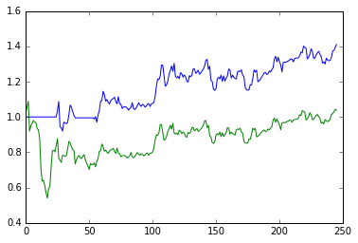

|  | dt | type | price | size | value | commission | pnl |
| --- | --- | --- | --- | --- | --- | --- | --- |
| 0 | 2020-03-30 | buy | 14.12 | 7022 | 99150.639196 | 743.629794 | 0.000000 |
| 1 | 2020-03-31 | buy | 14.75 | 7 | 103.250000 | 0.774375 | 0.000000 |
| 2 | 2020-04-20 | sell | 14.26 | -7029 | 99253.889196 | 751.751562 | 979.652412 |
| 3 | 2020-05-11 | buy | 12.86 | 7670 | 98636.197367 | 739.771480 | 0.000000 |
| 4 | 2020-05-18 | buy | 13.48 | 7 | 94.359997 | 0.707700 | 0.000000 |

PAGS

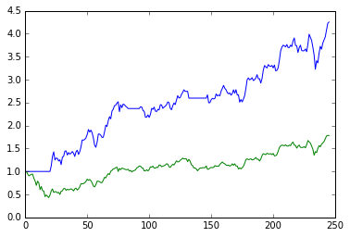

|  | dt | type | price | size | value | commission | pnl |
| --- | --- | --- | --- | --- | --- | --- | --- |
| 0 | 2020-03-24 | buy | 14.950000 | 6632 | 99148.398735 | 743.612991 | 0.000000 |
| 1 | 2020-03-30 | buy | 18.820000 | 5 | 94.099998 | 0.705750 | 0.000000 |
| 2 | 2020-06-22 | sell | 35.980000 | -6637 | 99242.498734 | 1790.994427 | 139556.758228 |
| 3 | 2020-07-07 | buy | 37.889999 | 6202 | 234993.776215 | 1762.453322 | 0.000000 |
| 4 | 2020-07-13 | buy | 37.169998 | 7 | 260.189987 | 1.951425 | 0.000000 |
| 5 | 2020-08-31 | sell | 42.139999 | -6209 | 235253.966202 | 1962.354422 | 26393.290009 |
| 6 | 2020-09-22 | buy | 37.520000 | 6862 | 257462.243141 | 1930.966824 | 0.000000 |
| 7 | 2020-09-28 | buy | 37.299999 | 7 | 261.099995 | 1.958250 | 0.000000 |

KMX

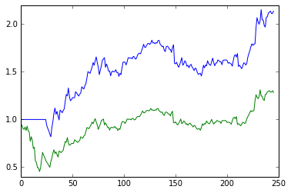

|  | dt | type | price | size | value | commission | pnl |
| --- | --- | --- | --- | --- | --- | --- | --- |
| 0 | 2020-03-30 | buy | 58.93 | 1682 | 99120.260513 | 743.401954 | 0.0 |
| 1 | 2020-03-31 | buy | 55.75 | 2 | 111.500000 | 0.836250 | 0.0 |

SPUU

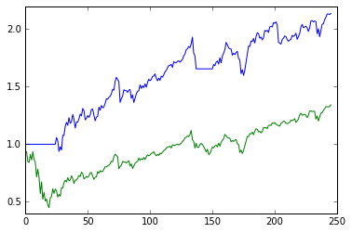

|  | dt | type | price | size | value | commission | pnl |
| --- | --- | --- | --- | --- | --- | --- | --- |
| 0 | 2020-03-30 | buy | 37.919998 | 2614 | 99122.875214 | 743.421564 | 0.000000 |
| 1 | 2020-03-31 | buy | 40.439999 | 3 | 121.319996 | 0.909900 | 0.000000 |
| 2 | 2020-09-08 | sell | 63.720001 | -2617 | 99244.195210 | 1250.664324 | 67511.047985 |
| 3 | 2020-09-28 | buy | 62.349998 | 2632 | 164105.195984 | 1230.788970 | 0.000000 |
| 4 | 2020-10-05 | buy | 64.379997 | 2 | 128.759995 | 0.965700 | 0.000000 |